Experiment 1

**1. pwd Command**

The pwd command is used to display the location of the current working directory.

**pwd COMMAND:**

pwd - Print Working Directory. pwd command prints the full filename of

the current working directory.

**SYNTAX:**

pwd [options]

**2. mkdir Command**

The mkdir[r](https://www.javatpoint.com/linux-mkdir) command is used to create a new directory under any directory.

**cd COMMAND:**

cd command is used to change the directory.

**SYNTAX:**

cd [directory | ~ | ./ | ../ | - ]

**3. rmdir Command**

The rmdir command is used to delete a directory.

**ls COMMAND:**

ls command lists the files and directories under current working directory.

**SYNTAX:**

The Syntax is

ls [OPTIONS]... [FILE]

**4. ls Command**

The ls command is used to display a list of content of a directory.

**rm COMMAND:**

rm command is used to remove/delete the file from the directory.

**SYNTAX:**

rm [options..] [file | directory]

**OPTIONS:**

CODE:-

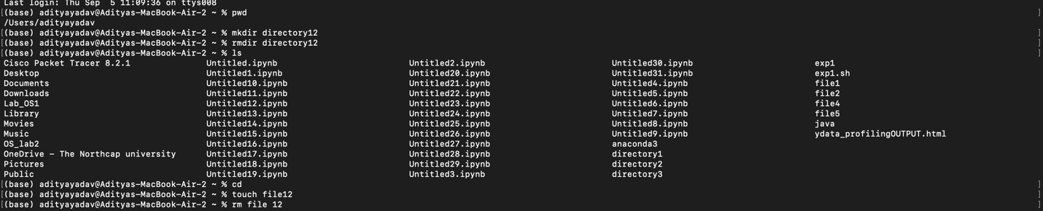

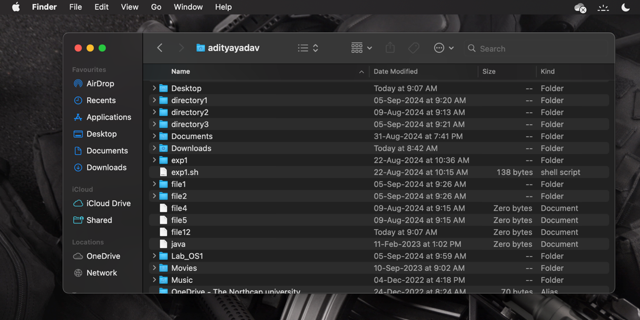

**5. cd Command**

The cd command is used to change the current directory. **mv COMMAND:**

mv command which is short for move. It is used to move/rename file

from one directory to another. mv command is different from cp command

as it completely removes the file from the source and moves to the directory

specified, where cp command just copies the content from one file to

another.

**SYNTAX:**

mv [-f] [-i] oldname newname

**OPTIONS:**

* -f:This will not prompt before overwriting (equivalent to --reply=yes).

mv -f will move the file(s) without prompting even if it is writing over an existing target.

* -i Prompts before overwriting another file.

**6. touch Command**

The touch command is used to create empty files. We can create multiple empty files by executing it once.

**cat COMMAND:**

cat command is used to create a new file and to display the contents of already existing file.

CODE : -





**7. cat Command**

The cat command is a multi-purpose utility in the Linux system. It can be used to create a file, display content of the file, copy the content of one file to another file, and more.

**cmp COMMAND:**

cmp command compares two files and tells you which line numbers are different.

**SYNTAX:**

cmp [options..] file1 file2

**OPTIONS:**

* c: Output differing bytes as characters.
* l:Print the byte number (decimal) and the differing byte values (octal) for each difference.
* s :Prints nothing for differing files, return exit status only.

**8. rm Command**

The rm command is used to remove a file.

**cp COMMAND:**

cp command copy files from one location to another. If the destination is an existing file, then the file is overwritten; if the destination is an existing directory, the file is copied into the directory (the directory is notoverwritten).

**SYNTAX:**

cp [OPTIONS]... SOURCE DEST

9. ping Command

Used for checking network connectivity.

**bc COMMAND:**

 bc command is used for command line calculator. It is similar to basic calculator. By using which we can do basic mathematical calculations.

CODE :-

10. grep Command

This command used in searching and matching text files

**echo COMMAND:**

echo command prints the given input string to standard output.

CODE :-

**12) paste COMMAND:**

paste command is used to paste the content from one file to another file. It is

also used to set column format for each line.

**SYNTAX:**

paste [options]

**OPTIONS:**

* -s Paste one file at a time instead of in parallel.
* -d Reuse characters from LIST instead of TABs

**13) rmdir COMMAND:**

rmdir command is used to delete/remove a directory and its subdirectories.

**SYNTAX:**

The Syntax is

rmdir [options..] Directory

**OPTIONS:**

* -p:Allow users to remove the directory dir name and its parentdirectories which become empty.
* s will suppress standard error messages caused by –p
* r  will remove all files even if directory is not empty

**14) wc COMMAND:**

wc command counts the characters, words or lines in a file depending upon the option.

**SYNTAX:**

wc [options..] Filename

**OPTIONS:**

* -l filename will print total number of lines in a file.
* -w filename will print total number of words in a file.

-c filename will print total number of characters in a file.

CODE :-

**15) cal COMMAND:**

cal command will print the calendar of current month by default.

**SYNTAX:**

cal [options..]

**example:** cal 8 1965

This will print calendar of august of 1965.

August 1965

S M Tu W Th F S

1 2 3 4 5 6 7

8 9 10 11 12 13 14

15 16 17 18 19 20 21

22 23 24 25 26 27 28

29 30 31

**16) clear COMMAND:**

clear command clears the screen and puts cursor at beginning of first line.

**SYNTAX:** clear

**17) tty COMMAND:**

Tty command will display your terminal

**SYNTAX:**

tty options

**OPTIONS:**

* -l will print the synchronous line number.
* -s will return only the codes: 0 (a terminal), 1 (not a terminal), 2 (invalid options) (good for scripts)

CODE :-

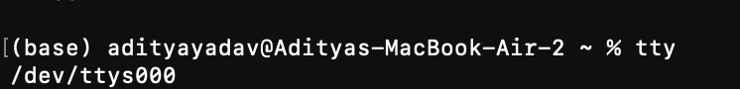

**18) banner COMMAND:**

banner prints characters in a sort of ascii art poster.

**SYNTAX:**

Banner word

**eg: banner wait**

# # ## # #####

# # # # # #

# # # # # #

# ## # ###### # #

## ## # # # #

# # # # # #

CODE:-

**19) who COMMAND**: tells you who's logged on, and where they're coming from. Useful if you're looking for someone who's actually physically in the same building as you, or in some other particular location.

**SYNTAX:**

Who

**20) date COMMAND:**

Date command prints or sets the system date and time

**SYNTAX:**

date [options..]

**21**) **chmod COMMAND:** Changes the [permissions](http://www.computerhope.com/jargon/p/permissi.htm) of a file or directory.

**SYNTAX:**

chmod [options..] mode filename

**example:** chmod 644 filename

This command will give all permissions to the owner (i.e read, write and execute) while read and execute permissions only to others and group.

**22) touch COMMAND:**

Touch command is used to create a new empty file.

**SYNTAX:**

touch filename

**23) uname COMMAND:**

Print information about the current system.

**24) ps COMMAND:**

The **ps** command displays active processes.

**SYNTAX:**

ps [Options..]

**25) exit COMMAND:**

Issuing the **exit** command at the shell prompt will cause the shell to exit.

**SYNTAX:**

exit

